SIMATS ENGINEERING (SAVEETHA SCHOOL OF ENGINEERING)
Department of Artificial Intelligence and Machine Learning

ASSESSMENT TOOL 1 – Analytical Problem Solving (5 QUESTIONS)

Course Code: | MLA0407 | Course Title: | Deep Learning
CO Assessed: | CO1 | Assessment: | Assessment Tool 3 – Experiments
Weightage: | 35% of CIA | Total Marks: | (5 Questions × 10 Marks)
CO1 Statement: | Apply the fundamental concepts of machine learning and neural networks to design and analyze learning algorithms using perceptrons, multilayer perceptrons, forward propagation, backpropagation, gradient descent optimization techniques, and Maximum Likelihood  Estimation for solving real-world problems.
Student Name: | Thanmai Reddy | Reg. No.: | 192425372
Section / Batch: |  | Date:

Code of Conduct
I Thanmai Reddy (192425372) (NAME/ REG NO) certify that this submission is my original work and that I have adhered to the guidelines specified for this assessment. I understand that any violation of academic integrity rules

will result in disciplinary action. Signature of the Student:

Name: - T. Thanmai Reddy Course code: - MLA0407
Reg no: - 192425372 Course Name: - Deep Learning

Experiment 1: Implementation of a Single Artificial Neuron Objective: Implement a single artificial neuron using Python. Task: Total Marks: 50 Annexure A Experiments
Program: -
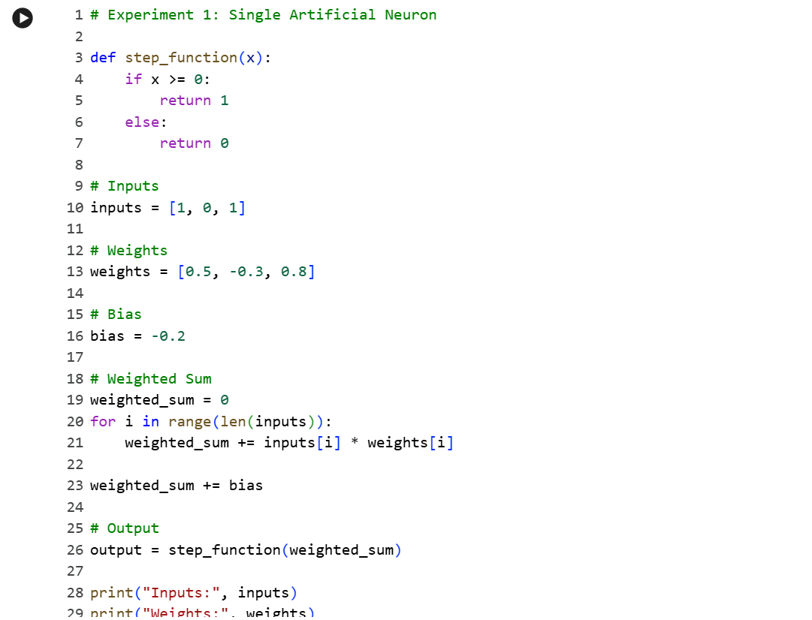
Output: -
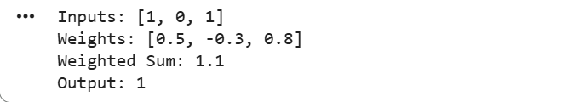
Result: -
The artificial neuron successfully computed the weighted sum and produced the correct binary output using the step activation function.
Experiment 2: Perceptron for AND Gate Objective: Implement the Perceptron Learning Algorithm. Task:
Program: -
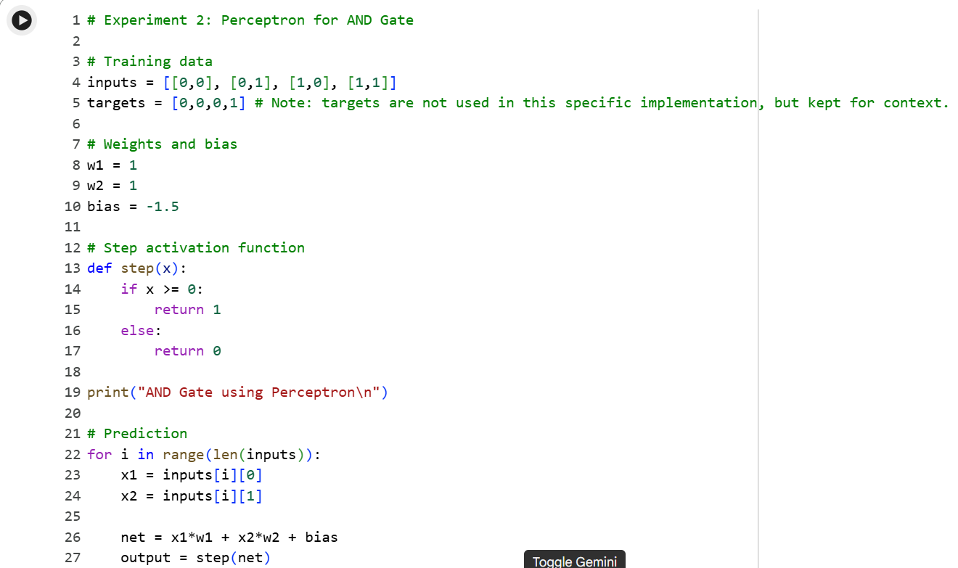
Output: -
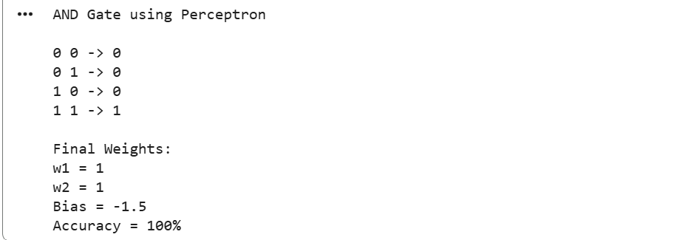
Result: -
The perceptron correctly classified the AND gate with 100% accuracy.

Experiment 3: Perceptron for OR Gate Objective: Design a perceptron model for binary classification. Task: Implement a perceptron to classify the OR logic gate.
Program: -
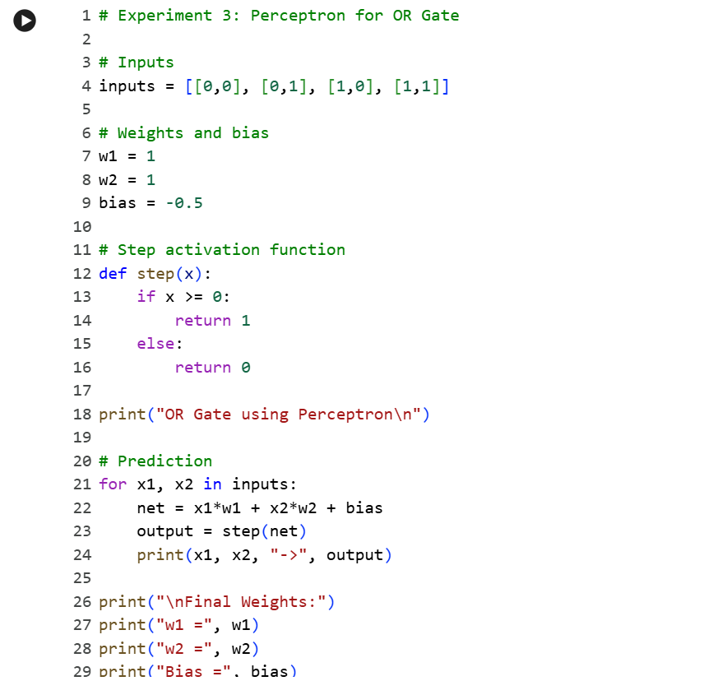
Output: -
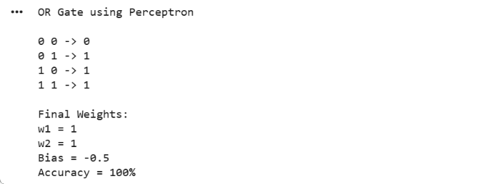
Result: -
The perceptron correctly classified the OR gate with 100% accuracy.
Experiment 4: XOR Classification Analysis Objective: Study the limitations of a single-layer perceptron. Task: Attempt to train a perceptron for the XOR logic gate.
Program: -
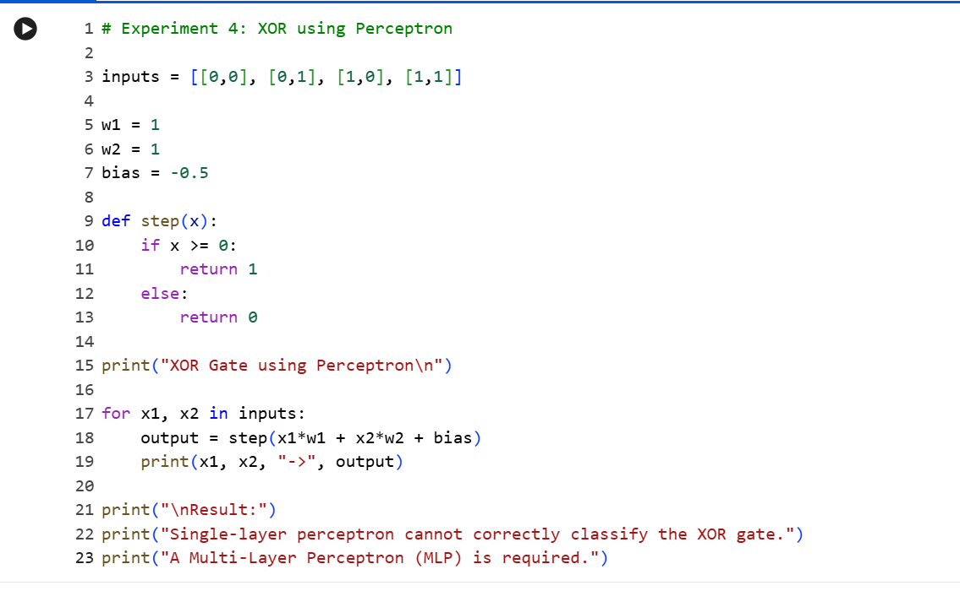

Output: -
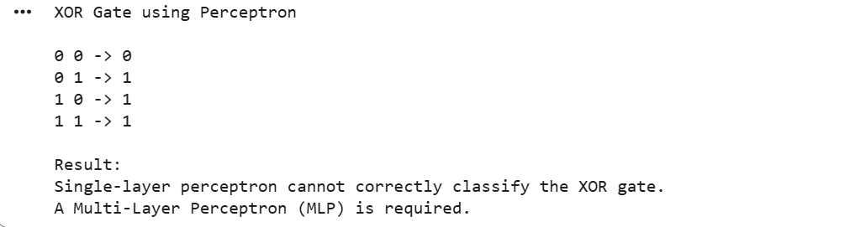
Result: -
The single-layer perceptron failed to classify the XOR gate because it is not linearly separable.

Experiment 5: Gradient Descent Optimization Objective: Understand Gradient Descent. Task: Implement the Gradient Descent algorithm to minimize a simple quadratic cost function.
Program: -
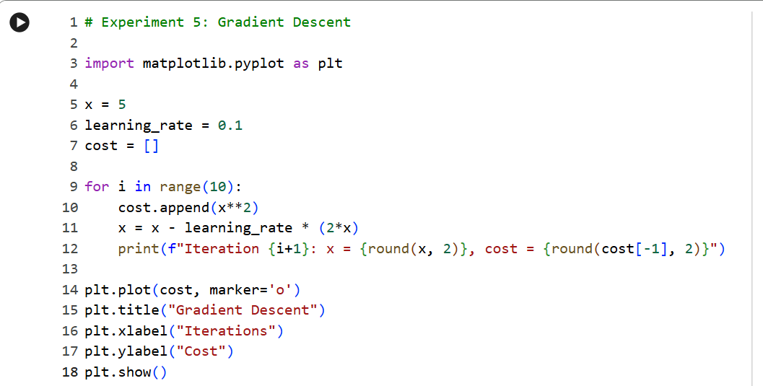

Output: -
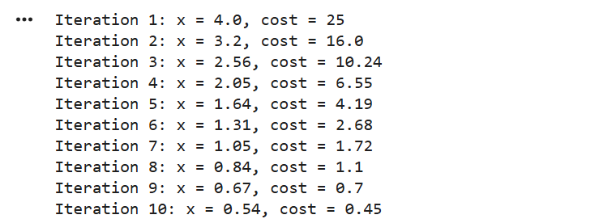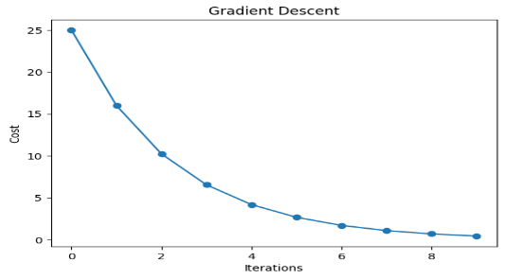

Result: -
Gradient Descent successfully minimized the cost function, showing convergence over the iterations.

Rubrics for Calculation

Criteria | Weightage | Level 4 (Exemplary) | Level 3 (Proficient) | Level 2 (Developing) | Level 1 (Beginning)
Technical Content Accuracy | 30 | Highly accurate, indepth, and insightful technical explanation | Technically correct content with adequate depth and  clarity | Basic concepts presented with limited accuracy and depth | Content contains major technical errors; concepts poorly  understood
Problem  Identification | 25 | Problem rigorously analyzed using appropriate and advanced methods | Problem clearly defined with a logical engineering approach | Problem identified but analysis or methodology is  weak | Problem statement unclear or incorrect; no  logical approach
Use of Tools | 20 | Advanced tools, well-analyzed data, and highly effective visuals | Appropriate tools and data used effectively with clear  visuals | Limited use of tools and basic data interpretation | Minimal or incorrect use of tools and data; poor visuals
Communication | 15 | Highly engaging, confident, and audience-focused delivery | Clear, organized, and professional  communication | Understandable but lacks clarity, structure, or  confidence | Poor organization, unclear speech, ineffective slides
Professionalism | 10 | Exemplary professionalism, leadership, and ethical awareness | Professional conduct with effective team collaboration | Basic professionalism; uneven team participation | Lacks professionalism; minimal contribution or ethical awareness

Faculty In-charge | Course Coordinator | Program Director
Signature: | Signature: | Signature:
Date: | Date: | Date:

